Earthquake Report for Argentina on 2021-01-19

# Hazard Description

On January 19, 2021, at approximately 3:46 local time, a magnitude 6.4 earthquake, with a depth of 20.0 km, struck 27 km Southwest of of Pocito, Argentina. The coordinate of epicenter of the earthquake was 31.8232°S, 68.8182°W.

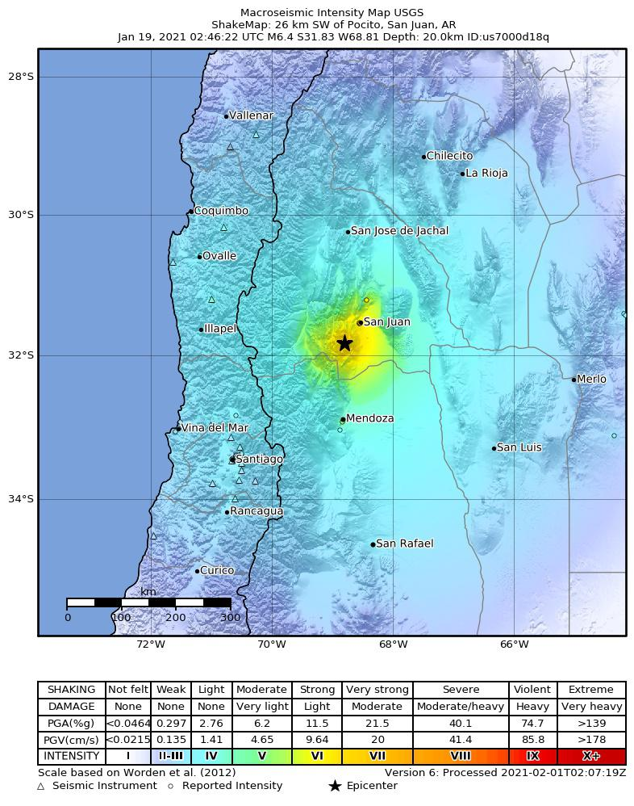

The South American arc extends over 7,000 km, from the Chilean margin   
triple junction offshore of southern Chile to its intersection with the Panama   
fracture zone, offshore of the southern coast of Panama in Central America.   
It marks the plate boundary between the subducting Nazca plate and the   
South America plate, where the oceanic crust and lithosphere of the Nazca   
plate begin their descent into the mantle beneath South America. The   
convergence associated with this subduction process is responsible for the   
uplift of the Andes Mountains, and for the active volcanic chain present along   
much of this deformation front. Relative to a fixed South America plate, the   
Nazca plate moves slightly north of eastwards at a rate varying from   
approximately 80 mm/yr in the south to approximately 65 mm/yr in the north.   
Although the rate of subduction varies little along the entire arc, there are   
complex changes in the geologic processes along the subduction zone that   
dramatically influence volcanic activity, crustal deformation, earthquake   
generation and occurrence all along the western edge of South America.  
  
Most of the large earthquakes in South America are constrained to shallow   
depths of 0 to 70 km resulting from both crustal and interplate deformation.   
Crustal earthquakes result from deformation and mountain building in the   
overriding South America plate and generate earthquakes as deep as   
approximately 50 km. Interplate earthquakes occur due to slip along the   
dipping interface between the Nazca and the South American plates.   
Interplate earthquakes in this region are frequent and often large, and occur   
between the depths of approximately 10 and 60 km. Since 1900, numerous   
magnitude 8 or larger earthquakes have occurred on this subduction zone   
interface that were followed by devastating tsunamis, including the 1960 M9.5   
earthquake in southern Chile, the largest instrumentally recorded earthquake in   
the world. Other notable shallow tsunami-generating earthquakes include the   
1906 M8.5 earthquake near Esmeraldas, Ecuador, the 1922 M8.5 earthquake   
near Coquimbo, Chile, the 2001 M8.4 Arequipa, Peru earthquake, the 2007   
M8.0 earthquake near Pisco, Peru, and the 2010 M8.8 Maule, Chile earthquake   
located just north of the 1960 event.  
  
Large intermediate-depth earthquakes (those occurring between depths of   
approximately 70 and 300 km) are relatively limited in size and spatial extent in   
South America, and occur within the Nazca plate as a result of internal   
deformation within the subducting plate. These earthquakes generally cluster   
beneath northern Chile and southwestern Bolivia, and to a lesser extent beneath   
northern Peru and southern Ecuador, with depths between 110 and 130 km. Most   
of these earthquakes occur adjacent to the bend in the coastline between Peru   
and Chile. The most recent large intermediate-depth earthquake in this region was   
the 2005 M7.8 Tarapaca, Chile earthquake.  
  
Earthquakes can also be generated to depths greater than 600 km as a   
result of continued internal deformation of the subducting Nazca plate.   
Deep-focus earthquakes in South America are not observed from a depth   
range of approximately 300 to 500 km. Instead, deep earthquakes in this   
region occur at depths of 500 to 650 km and are concentrated into two   
zones: one that runs beneath the Peru-Brazil border and another that   
extends from central Bolivia to central Argentina. These earthquakes   
generally do not exhibit large magnitudes. An exception to this was the   
1994 Bolivian earthquake in northwestern Bolivia. This M8.2 earthquake occurred at a depth of 631 km, which was until recently the largest deep-focus earthquake instrumentally recorded (superseded in May 2013 by a M8.3 earthquake 610 km beneath the Sea of Okhotsk, Russia), and was felt widely throughout South and North America.  
  
Subduction of the Nazca plate is geometrically complex and impacts the geology   
and seismicity of the western edge of South America. The intermediate-depth   
regions of the subducting Nazca plate can be segmented into five sections based   
on their angle of subduction beneath the South America plate. Three segments are   
characterized by steeply dipping subduction; the other two by near-horizontal   
subduction. The Nazca plate beneath northern Ecuador, southern Peru to northern   
Chile, and southern Chile descend into the mantle at angles of 25° to 30°. In contrast,   
the slab beneath southern Ecuador to central Peru, and under central Chile, is   
subducting at a shallow angle of approximately 10° or less. In these regions of   
“flat-slab” subduction, the Nazca plate moves horizontally for several hundred   
kilometers before continuing its descent into the mantle, and is shadowed by an   
extended zone of crustal seismicity in the overlying South America plate. Although the   
South America plate exhibits a chain of active volcanism resulting from the subduction   
and partial melting of the Nazca oceanic lithosphere along most of the arc, these   
regions of inferred shallow subduction correlate with an absence of volcanic activity.  
  
  
More information on regional seismicity and tectonics

# Buildings

The interior ministry said on Twitter that a tremor of magnitude 7.1 struck at 8.36 p.m. 216 km northeast of the O’Higgins Chilean scientific base and called for the coastal regions of Antarctica to be evacuated because of a tsunami risk. In a time of both misinformation and too much information, quality journalism is more crucial than ever.By subscribing, you can help us get the story right. The army said no damage was reported at the Antarctic base.

# Infrastructure

The ministry also sent a message to cellphones around the country urging people to abandon coastal areas, though the ministry later said it was sent in error.

# Resilience

But as Chileans were reacting to the warning, a second tremor, of magnitude 5.6, struck the Chile-Argentina border region, at 9.07 p.m., the GFZ German Research Center for Geosciences said, at a depth of 133 km and 30km east of Santiago.